

IMPLEMENT PROCESS

**Version 1.0**

**Thang Nguyen**

**05/05/2017**

**Revision History**

|  |  |  |  |
| --- | --- | --- | --- |
| **Version** | **Date** | **Author** | **Content** |
| 1.0 | 05/05/2017 | Thang Nguyen | Make Implementation process document version 1.0 |

Table of Contents

**1. INTRODUCTION 5**

1.1 PROJECT OVERVIEW 5

1.2 PURPOSE 6

1.3 INTENDED AUDIENCE 6

**2. IMPLEMENT PROCESS 7**

2.1 RESEARCH 8

*2.2* *PREPARE* 9

*2.3* *TRAIN* 10

*2.4* *CUSTOMIZE* 10

2.5 RELEASE 12

**3. REFERENCE 13**

**List of Table**

Table 1. Intended Audience 6

Table 2. Describe Research Step 8

Table 3. Describe Prepare step 9

Table 4. Describe Train step 10

Table 5. Describe Customize Step 11

Table 6 . Describe Release step 12

**List of Figure**

Figure 1. Implement Process 7

1. **Introduction.**
   1. **Project Overview**

* The Faculty of Information Technology wants to build a system to support the management of student training and learning. Building a system will take a lot of time and effort, so the department will break down the system into independent parts for implement in many stages. With the desire to inform parents of their children's learning situation, the Faculty will build a module for electronic communication so parents can easily catch information.

* 1. **Purpose**
* This document describes in detail the process – which will use to define the Programing Software.
* The process will be started right after the end of Architectural phase, using SRS (Software Requirement Specification) and Detail Design document as the input.
* By the name of this process, the final output will be Process for Coding Phase document.
  1. **. Intend Audience**

|  |  |  |
| --- | --- | --- |
| **Intended Audience** | **Name** | **Reading Suggestions** |
| Implement Leader | * Thang Nguyen | Deploy set of implement process include processes, describes for all member in team can understand and do right process. |
| Programmer | * Nhat Tan * Qui Ngo * Van Phan * Nhuan Tran | Read document to know Implement process and according it to work in Implement phase. |
| Project Manager | * Van Phan | Read to know process of implement phase and tracking progress according to this process. |

Table 1. Intended Audience

1. **Implement Process**

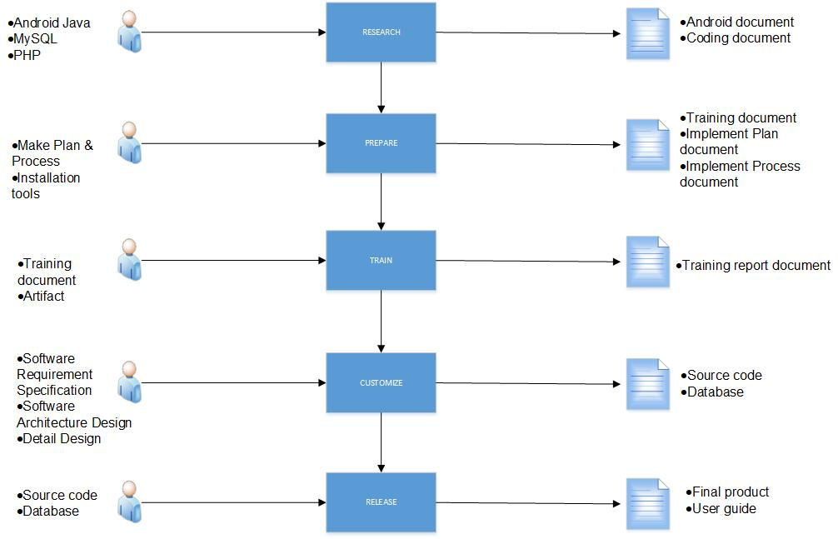

Figure 1. Implement Process

* 1. **Research**

|  |  |
| --- | --- |
| **ID** | **01** |
| **Process Name** | **Research** |
| **Purpose** | Purpose of research phase help implement leader can identify framework , database and language programing necessary before executing project. |
| **Entry & Exit conditions Criteria** | * **Entry:** Implement leader identify language programing , database and framework * **Exit :** have a set of the document about code and framework |
| **Input** | * Android Language * MySQL * Sublime Text ( PHP ) |
| **Output** | * Android document * Coding document |
| **Role** | **Implement leader** |
| **Responsibility** | * Research Android Studio:   Android Studio is basic component help to build the Application   * PHP & MySQL:   Language programing(PHP) and database(MySQL) allow implement leader to code and save data to the database |
| **Tools** | * Microsoft Word |
| **Measurement(s)/Metrics** |  |
| **Training & References** |  |
| **Template** |  |

Table 2. Describe Research Step

* 1. **Prepare**

|  |  |
| --- | --- |
| **ID** | **02** |
| **Process Name** | **Prepare** |
| **Purpose** | Purpose of preparation phase help implement leader can prepare everything necessary before executing training step. |
| **Entry & Exit conditions Criteria** | * **Entry:** Implement leader identify plan & process * **Exit :** have a set of the implement phase document fully and work according to WBS |
| **Input** | * Make Plan & Process * Installation tools : Android Studio , MySQL , Sublime Text |
| **Output** | * Training document * Implement Plan document * Implement Process document * Installation guide document |
| **Role** | **Implement leader** |
| **Responsibility** | * Make Plan & Process :   Implement leader will be scheduled from the beginning and then design set of the process for implement phase .According , implement leader base on tracking and controlling.   * Installation tools:   Before starting training , we have to install tools necessary as Android Studio , MySQL , |
| **Tools** | * Microsoft Word |
| **Measurement(s)/Metrics** | **The finished time of this process**   * 1 day = good (identified all needed factors and stakeholders) * 2 days = average * 3 days = bad |
| **Training & References** |  |
| **Template** |  |

Table 3. Describe Prepare step

* 1. **Train**

|  |  |
| --- | --- |
| **ID** | **03** |
| **Process Name** | **Train** |
| **Purpose** | After prepare step, implement leader will train all knowledge as Android Studio, PHP, MySQL to all member in team until they can understand and apply to the project. |
| **Entry & Exit conditions Criteria** | * **Entry:** The preparation phase is finished * **Exit :** having knowledge overview about the system website. |
| **Input** | * Training document * Artifact |
| **Output** | * Training report document |
| **Role** | **Implement leader** |
| **Responsibility** | * After the preparation is finished , implement leader will train |
| **Tools** | * Microsoft Word, Sublime Text, Xampp, MySQL * Technique : Estimate , Language programming. |
| **Measurement(s)/Metrics** | **Number of function per days**   * 1 function/ day = good * 1 function/ 2 days = average * 1 function/ 3 days = bad |
| **Training & References** | * Trainer : Implement leader. |
| **Template** |  |

Table 4. Describe Train step

* 1. **Customize**

|  |  |
| --- | --- |
| **ID** | **04** |
| **Process Name** | **Customize** |
| **Purpose** | Executing customize according to requirement specification and architecture & detail design document |
| **Entry & Exit conditions Criteria** | * **Entry:** The preparation phase is finished * **Exit :** having set of source code & database. |
| **Input** | * Software Requirement Specification * Software Architecture Design * Detail Design |
| **Output** | * Source code * Database |
| **Role** | **Implement leader**  **Programmer** |
| **Responsibility** | * After that the training is finished , develop team will customize the website system from front-end to back-end. * Before customize , the develop team base on software requirement specification document, architecture and detail design document to custom Android Studio and release source code and database. |
| **Tools** | * Microsoft Word, Sublime Text, Xampp, MySQL server. * Technique : Estimate , Language programming. |
| **Measurement(s)/Metrics** | **Number of function per days**   * 1 function/ day = good * 1 function/ 2 days = average * 1 function/ 3 days = bad |
| **Training & References** | * Trainer : Implement leader , Requirement leader and Architect and Design leader. |
| **Template** | * Detail Design * SAD * SRS |

Table 5. Describe Customize Step

* 1. **Release**

|  |  |
| --- | --- |
| **ID** | **05** |
| **Process Name** | **Release** |
| **Purpose** | This phase will delivery for customer final product which maintain & improve  Otherwise User guide document and Refection. |
| **Entry & Exit conditions Criteria** | * **Entry:** The Customize step is finished. * **Exit :** Final product & guide document. |
| **Input** | * Source code * Database |
| **Output** | * Final product * User guide |
| **Role** | * Implement leader * Programmer |
| **Responsibility** | * Develop team use source code & database sufficient write user guide document and final product for end- user. |
| **Tools** | * Microsoft Word, The burning software |
| **Measurement(s)/Metrics** | **The finished time of this process**   * 1 day = good (all product & guide document are completed ) * 2 days = bad (can accept) * 3 days = very bad (too late progress) |
| **Training & References** |  |
| **Template** |  |

Table 6 . Describe Release step

1. **Reference**